A close up of a logo

Description generated with high confidenceCity Battles

What is the game? /Narrative

The game is a mix between both Battle Royale and First-Person Shooter (FPS) games. It will have a cartoon war theme similar to that of games like Clash of Clans. All players are against each other and there’s a maximum player limit of 100 players on the map. All players will be dropped into the map from military aircrafts and will need to find loot such as weapons to have a better chance of winning the game.

Game Genre

Like stated before, my game will implement components of both Battle Royale and First-Person Shooter games. This is because they are some of the most loved and played game types. As it is using the angle of First-Person, you will feel more immersed within the game. This is important, as you want the player to feel like they are there in real life. The Battle Royale concept is based around trying to be the last player alive, just like in the book/film ‘The Hunger Games’. It also exploits the idea of finding items, which you can use in different ways to eliminate enemies and win the game.

Similar Games

The games that were a stimulus for my game were H1Z1, Battlegrounds, Call of Duty and Counter Strike. I like the idea of how Battle Royale games have a large community of players, who compete to be the best. It’s also a more realistic game style, which seems to use the idea of the Hunger Games. My game will be similar to Call of Duty, as it uses some of its main features, such as being in First Person, choosing multiple guns, attachments and vast customization.

Unique Selling Point

At this moment in time there are no Battle Royale games that take advantage of the First-Person Shooter genre and its immersive feel. Therefore, I believe that the gaming market will enjoy playing an FPS Battle Royale game, which will make them feel immersed in their surroundings. The other unique selling point is the competitive mode, which allows players to compete against each other to get the best ranks. If a game has ranks, showing who is better, it makes a game very addictive, as people compete against their friends. Furthermore, there is a lot of individual pieces of customization that people can earn within the game.

Target Audience

As this is a war based game, with blood and gory, the target audience will be 16 plus. As there is a ranking system involved within every element of the game, it may not entice the casual, everyday player. I would say that this game would be aimed at males, however the female gaming community has grown, so both genders would be enticed. Following this, avid gamers love to play a competitive mode, so they can show off how good they are at the game, compared to their peers.

Platform

The target platform for the game I am designing, would be PC. This is because the game controls would be complex, and advanced PCs will be able to run the game much better. There would be different video settings, so players with lower end PCs could still play on lower settings. Despite this, in the future, I would like to see if it could be altered slightly for use on consoles such as the Xbox One and PS4. This would be good, as it would reach the more casual gamer. Thus, extending the audience.

What do you control?

In City Battles you control a single character, which you can customize until your hearts content. You will control all the characters actions such as shooting the weapon, sprinting, sliding and so on. However, as you need to be the last alive, the main action is utilizing your weapon and handling a knife in close quarters. As there will also be a ‘Duos’ mode, to play with friends, if you die you will be able to control what you see of their view, through spectating. This is so you aren’t too bored when waiting to play another game with them. You can also aid your teammate in winning the game, as you will still get winning XP.

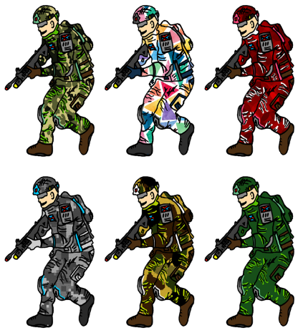Characters

There’s only one main character you can be within the game, and that’s basically yourself. You need to imagine that you’re in a ‘Hunger Games’ like environment, where you will need to fight your way out to survive and win the game. As this is a multiplayer game I have allowed players to have lots of customization. You can receive customization through playing the game and randomly earning pieces, or buy them from the store, through an in-game currency.

I have not got any non-playing characters within my game, City Battles. This is because my game is solely based around online multiplayer.

Abilities

Each player can choose from a set of 5 different characters, who have a set of different perks and abilities. You would have to select the perks that most suit your game style. Each character’s perks and abilities would do something different, allowing you to play in a different way. The 5-character sets are called, Rapid, Armor, Sharp Shooter, Ghost and Yeti. For example, one character may be much quicker, however, another character may be slower but have some type of armor.

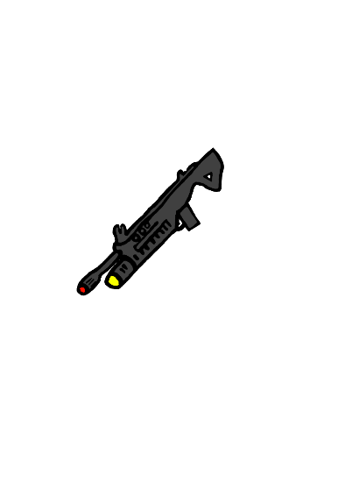A close up of a logo

Description generated with high confidence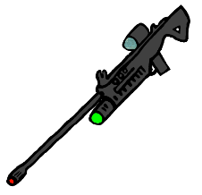Weapons

A close up of a knife

Description generated with high confidenceThere are 4 main weapons in my game, which will have different reasons to use them. In order (left to right) the names of the guns are, Glock 38, Beryl, OSV 9 and the Kataquo.

Setting/Key Location

A picture containing music

Description generated with high confidenceThe game is located in a modern city with suburban and forest areas surrounding it. Some of the buildings have now either fallen down, been set on fire or fully are still fully functional. In the suburbs, there will be tight built up areas, with standard family homes. Some of these homes will be broken due to the war that broke out. The forest environment will be full of large trees and some open grass land. Here, players can hide within the trees to sneak up behind other unsuspecting players. Although there are other areas surrounding the city, there will be large sky scrapers in the city center, where the best loot can be found or utilized by snipers.

Ranking System

The ranking system that I am implementing will have 5 main ranks, followed by 10 individual levels within each rank.

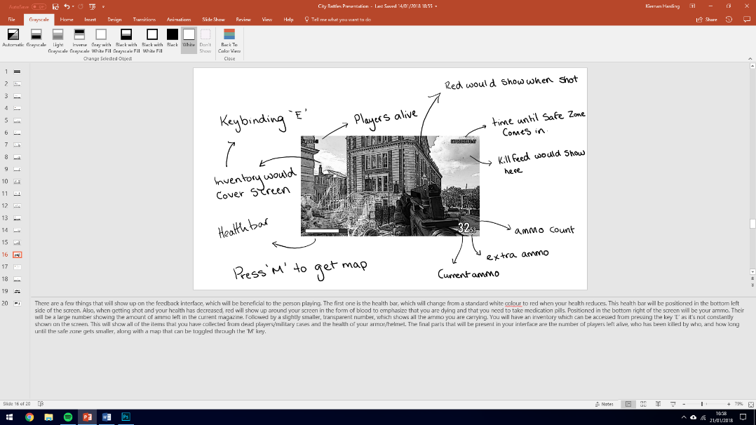Rewards

There are many ways you can be rewarded within City Battles. For example, after every game you can get XP, and possibly some common customisation pieces. The customisation pieces you may receive after a game won’t be the best. This is because you will be able to unlock the better customisation through earning lots of XP. For example, one of the best camouflages will be the classic Gold Camo, but you will need to receive a lot of XP to get it.